PROGRAM:

import csv
# Read CSV file
with open("job_data.csv") as file:
data = list(csv.reader(file))
# Separate header and training data
header = data[0]
training_data = data[1:]
print("Header:", header)
print("\nTraining Data:")
for row in training_data:
print(row)
# Initialize Specific Boundary (S)
S = training_data[0][:-1]
# Initialize General Boundary (G)
G = [["?" for i in range(len(S))] for i in range(len(S))]
# Candidate Elimination Algorithm
for i, example in enumerate(training_data):
if example[-1] == "Yes": # Positive Example
for j in range(len(S)):
if example[j] != S[j]:
S[j] = "?"
G[j][j] = "?"
elif example[-1] == "No": # Negative Example
for j in range(len(S)):
if example[j] != S[j]:
G[j][j] = S[j]
else:
G[j][j] = "?"
print("\nStep", i + 1)
print("S =", S)
print("G =", G)
print("\nFinal Output")
print("Specific Boundary (S):", S)
print("General Boundary (G):", G)

OUTPUT:
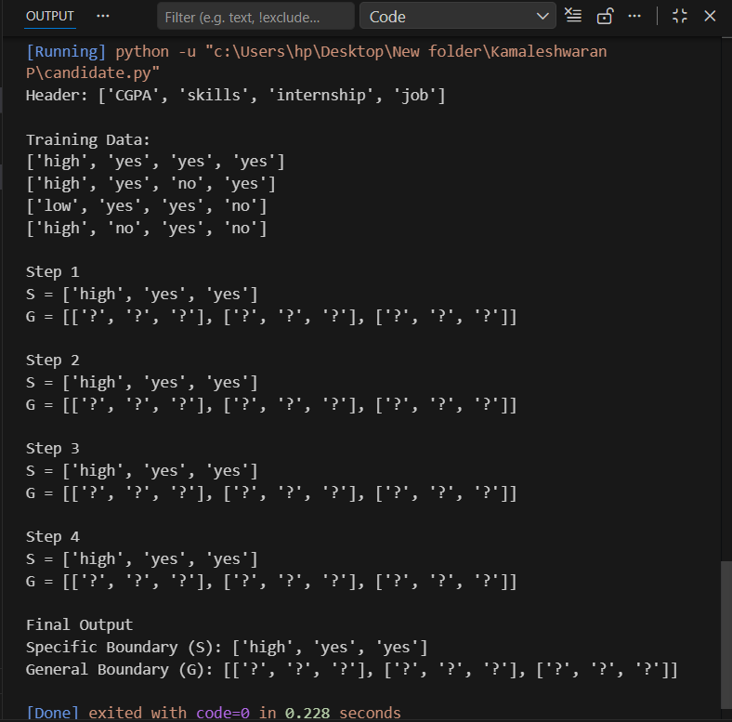
PROGRAM:
import csv
import math
def read_csv(file):
with open(file, newline='') as f:
reader = csv.reader(f)
header = next(reader)
data = [row for row in reader]
return header, data
def entropy(col):
counts = {}
for val in col:
counts[val] = counts.get(val, 0) + 1
ent = 0
for count in counts.values():
p = count / len(col)
ent -= p * math.log2(p)
return ent
def gain_ratio(data, col_idx):
target_col = [row[-1] for row in data] # Always last column
total_entropy = entropy(target_col)
vals = set(row[col_idx] for row in data)
weighted_entropy = 0
split_info = 0
for v in vals:
subset = [row for row in data if row[col_idx] == v]
ratio = len(subset) / len(data)
subset_target = [row[-1] for row in subset]
weighted_entropy += ratio * entropy(subset_target)
split_info -= ratio * math.log2(ratio)
if split_info == 0:
return 0
info_gain = total_entropy - weighted_entropy
return info_gain / split_info
def build_tree(data, attributes):
target_col = [row[-1] for row in data]
if target_col.count(target_col[0]) == len(target_col):
return target_col[0]
if not attributes:
return max(set(target_col), key=target_col.count)
gains = [gain_ratio(data, i) for i in range(len(attributes))]
best_idx = gains.index(max(gains))
best_attr = attributes[best_idx]
tree = {best_attr: {}}
values = set(row[best_idx] for row in data)
for v in values:
subset = []
for row in data:
if row[best_idx] == v:
# Remove best attribute column
new_row = row[:best_idx] + row[best_idx+1:]
subset.append(new_row)
new_attributes = attributes[:best_idx] + attributes[best_idx+1:]
if not subset:
tree[best_attr][v] = max(set(target_col), key=target_col.count)
else:
tree[best_attr][v] = build_tree(subset, new_attributes)
return tree
def print_tree(tree, indent=""):
if isinstance(tree, dict):
for key in tree:
print(indent + str(key))
for value in tree[key]:
print(indent + " ->", value)
print_tree(tree[key][value], indent + " ")
else:
print(indent + "Answer:", tree)
filename = "tennis.csv"
attributes, data = read_csv(filename)
tree_c45 = build_tree(data, attributes[:-1])
print("\n--- C4.5 Decision Tree ---")
print_tree(tree_c45)

OUTPUT:
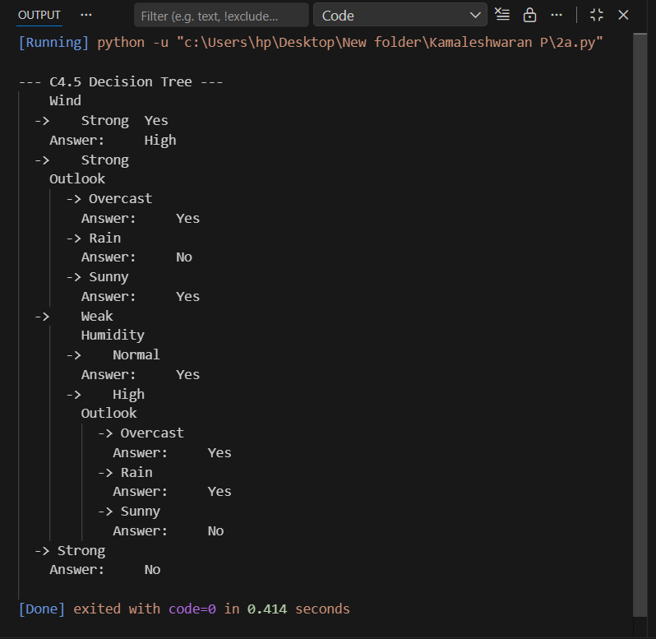
PROGRAM:
import csv
import math
def read_csv(file):
with open(file, newline='') as f:
reader = csv.reader(f)
header = next(reader)
data = [row for row in reader]
return header, data
def entropy(col):
counts = {}
for val in col:
counts[val] = counts.get(val, 0) + 1
ent = 0
for count in counts.values():
p = count / len(col)
ent -= p * math.log2(p)
return ent
def info_gain(data, col_idx):
target_col = [row[-1] for row in data]
total_entropy = entropy(target_col)
vals = set(row[col_idx] for row in data)
weighted_entropy = 0
for v in vals:
subset = [row for row in data if row[col_idx] == v]
ratio = len(subset) / len(data)
subset_target = [row[-1] for row in subset]
weighted_entropy += ratio * entropy(subset_target)
return total_entropy - weighted_entropy
def build_tree(data, attributes):
target_col = [row[-1] for row in data]
if target_col.count(target_col[0]) == len(target_col):
return target_col[0]
if not attributes:
return max(set(target_col), key=target_col.count)
gains = [info_gain(data, i) for i in range(len(attributes))]
best_idx = gains.index(max(gains))
best_attr = attributes[best_idx]
tree = {best_attr: {}}
values = set(row[best_idx] for row in data)
for v in values:
subset = []
for row in data:
if row[best_idx] == v:
new_row = row[:best_idx] + row[best_idx+1:]
subset.append(new_row)
new_attributes = attributes[:best_idx] + attributes[best_idx+1:]
if not subset:
tree[best_attr][v] = max(set(target_col), key=target_col.count)
else:
tree[best_attr][v] = build_tree(subset, new_attributes)
return tree
def print_tree(tree, indent=""):
if isinstance(tree, dict):
for key in tree:
print(indent + str(key))
for value in tree[key]:
print(indent + " ->", value)
print_tree(tree[key][value], indent + " ")
else:
print(indent + "Answer:", tree)
filename = "tennis.csv"
attributes, data = read_csv(filename)
tree_id3 = build_tree(data, attributes[:-1])
print("--- ID3 Decision Tree ---")
print_tree(tree_id3)

OUTPUT:
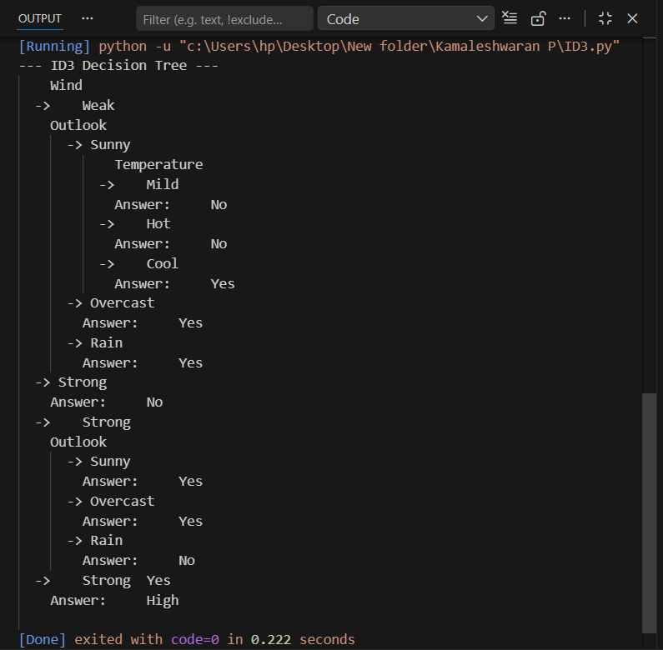
PROGRAM
from math import exp
from random import seed
from random import random
# Initialize a network
def initialize_network(n_inputs, n_hidden, n_outputs):
network = list()
# Hidden layer
hidden_layer = [{'weights': [random() for i in range(n_inputs + 1)]}
for i in range(n_hidden)]
network.append(hidden_layer)
# Output layer
output_layer = [{'weights': [random() for i in range(n_hidden + 1)]}
for i in range(n_outputs)]
network.append(output_layer)
return network
# Calculate neuron activation
def activate(weights, inputs):
activation = weights[-1] # bias
for i in range(len(weights) - 1):
activation += weights[i] * inputs[i]
return activation
# Sigmoid transfer function
def transfer(activation):
return 1.0 / (1.0 + exp(-activation))
# Forward propagation
def forward_propagate(network, row):
inputs = row
for layer in network:
new_inputs = []
for neuron in layer:
activation = activate(neuron['weights'], inputs)
neuron['output'] = transfer(activation)
new_inputs.append(neuron['output'])
inputs = new_inputs
return inputs
def transfer_derivative(output):
return output * (1.0 - output)
def backward_propagate_error(network, expected):
for i in reversed(range(len(network))):
layer = network[i]
errors = list()
if i != len(network) - 1: # hidden layer
for j in range(len(layer)):
error = 0.0
for neuron in network[i + 1]:
error += neuron['weights'][j] * neuron['delta']
errors.append(error)
else:
for j in range(len(layer)):
neuron = layer[j]
errors.append(neuron['output'] - expected[j])
for j in range(len(layer)):
neuron = layer[j]
neuron['delta'] = errors[j] * transfer_derivative(neuron['output'])
def update_weights(network, row, l_rate):
for i in range(len(network)):
inputs = row[:-1]
if i != 0:
inputs = [neuron['output'] for neuron in network[i - 1]]
for neuron in network[i]:
for j in range(len(inputs)):
neuron['weights'][j] -= l_rate * neuron['delta'] * inputs[j]
neuron['weights'][-1] -= l_rate * neuron['delta'] # update bias
# Train network
def train_network(network, train, l_rate, n_epoch, n_outputs):
for epoch in range(n_epoch):
sum_error = 0
for row in train:
outputs = forward_propagate(network, row)
expected = [0 for i in range(n_outputs)]
expected[row[-1]] = 1
sum_error += sum([(expected[i] - outputs[i]) ** 2
for i in range(len(expected))])
backward_propagate_error(network, expected)
update_weights(network, row, l_rate)
print('>epoch=%d, lrate=%.3f, error=%.3f' %
(epoch, l_rate, sum_error))
seed(1)
dataset = [
[2.7810836, 2.550537003, 0],
[1.465489372, 2.362125076, 0],
[3.396561688, 4.400293529, 0],
[1.38807019, 1.850220317, 0],
[3.06407232, 3.005305973, 0],
[7.627531214, 2.759262235, 1],
[5.332441248, 2.088626775, 1],
[6.922596716, 1.77106367, 1],
[8.675418651, -0.242068655, 1],
[7.673756466, 3.508563011, 1]
]
n_inputs = len(dataset[0]) - 1
n_outputs = len(set([row[-1] for row in dataset]))
network = initialize_network(n_inputs, 2, n_outputs)
train_network(network, dataset, 0.5, 20, n_outputs)
for layer in network:
print(layer)

OUTPUT:
